Need help with Medicare?
Ask SHIBA!

SHIBA Information Session
Join us to learn more about the Statewide Health Insurance Benefits Advisors (SHIBA) Program. SHIBA provides free, unbiased and confidential assistance with Medicare health care choices. SHIBA volunteers can help:
- Assess health care coverage needs
- Determine general eligibility for health care coverage programs
- Evaluate and compare health plans and programs
- Provide enrollment help with Medicare
- And more!

In this presentation we will discuss what the SHIBA program is, who we serve, what services we can provide and how to get in contact with a SHIBA volunteer.
This presentation will be at the Peter Kirk Senior and Community Center

Wednesday September 28th

1:30-3:00pm

Preregistration is required. To register please contact 425-587-3362

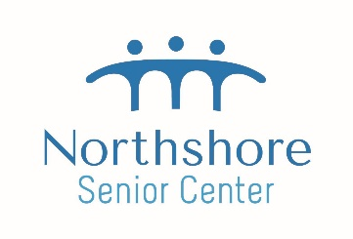

City, ST ZIP Code
Phone
Website

